Formula Sheet ACT MATH

Numbers, Sequences, Factors :

|  |  |
| --- | --- |
| Integers: | . . . , -3, -2, -1, 0, 1, 2, 3, . . . |
| Rationals: | fractions, that is, anything expressable as a ratio of integers |
| Reals: | Integers + rationals + special numbers such as √2, √3 and π |
| Order Of Operations: | PEMDAS  (Parentheses / Exponents / Multiply / Divide / Add / Subtract) |
| Arithmetic Sequences: | Sequence: t1, t1 + d, t1 + 2d, . . . |
| Geometric Sequences: | Sequence: t1,t1.r,t1.r2, . . . |
| Factors: | the factors of a number divide into that number  without a remainder  Example: the factors of 52 are 1, 2, 4, 13, 26, and 52 |
| Multiples: | the multiples of a number are divisible by that number  without a remainder  Example: the positive multiples of 20 are 20, 40, 60, 80, . . . |
| Percents: | use the following formula to find part, whole, or percent |

Averages, Counting, Statistics, Probability

|  |  |
| --- | --- |
| Average = |  |
| Average speed = |  |
| Sum = | Average (number of terms) |
| Mode = | value in the list that appears most often |
| Median = | middle value in the list |
| Fundamental Counting Principle | If an event can happen in N ways, & another, independent event can happen in M ways, then both events together can happen in  N ×M ways. (Extend this for three or more: N1 × N2 × N3 . . . ) |
| Probability |  |
| The probability of two different events A & B both happening | P(A and B) = P(A) P(B), as long as the events are independent (not mutually exclusive). |

Powers, Exponents, Roots

|  |  |
| --- | --- |
| xa . xb = | xa+b |
| (xa)b = | xa.b |
| xa/xb = | xa-b |
| 1/xb = | x-b |
| (xy)a = | xa . ya |
| x0 = | 1 |
| = |  |
| (-1)n = | +1, if n is even;  −1, if n is odd. |

Factor, Solving

|  |  |
| --- | --- |
| “FOIL” | (x + a)(x + b) = x2 + (b + a)x + ab |
| “Difference Of Squares” | a2 − b2 = (a + b)(a − b)  a2 + 2ab + b2 = (a + b)(a + b)  a2 − 2ab + b2 = (a − b)(a − b) |
| “Reverse FOIL” | x2 + (b + a)x + ab = (x + a)(x + b) |

Functions

|  |  |
| --- | --- |
| General representation | y = f(x). |
| Domain of f() | The set of possible values of x |
| Range of f() | the corresponding set of possible values of y |
| Absolute value | |x| = |
| If y = logb x | then the logarithm function gives the number y such that by = x. |
| Similarly, logb bn = n. |  |
| A useful rule to know is: | logb xy = logb x + logb y |

Complex Numbers

|  |  |
| --- | --- |
| i 0 = | 1 |
| i 1 = | i |
| i 2 = | -1 |
| i 3 = | -i |

Lines (Linear Functions)

|  |  |
| --- | --- |
| Distance from A to B: |  |
| Mid-point of the segment AB: |  |
| Slope of the line: |  |
| Point-slope form: | given the slope m and a point (x1, y1) on the line, the equation of the line is (y − y1) = m(x − x1). |
| Slope-intercept form: | given the slope m and the y-intercept b, then the equation of the line is y = mx + b |
| Parallel lines & Perpendicular lines | Parallel lines have equal slopes: m1 = m2  Perpendicular lines have negative reciprocal slopes:  m1 x m2 = −1. |
| Intersecting lines: | opposite angles are equal. Also, each pair of angles along the same line add to 180◦. In the figure below, a + b = 180◦ |
| Parallel lines: | eight angles are formed when a line crosses two parallel lines. The four big angles (a) are equal, and the four small angles (b) are equal. |

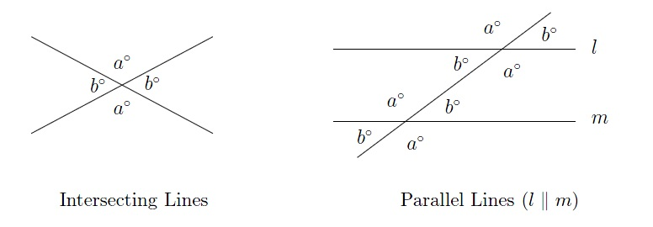

Triangles

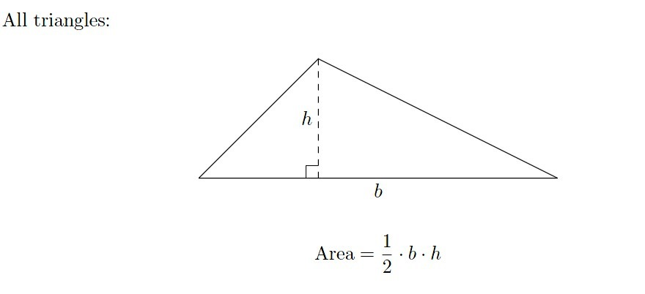

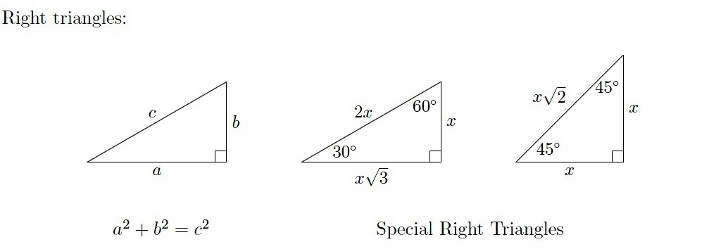

|  |  |
| --- | --- |
| Angles | Angles on the inside of any triangle add up to 180◦. |
| Angles | An exterior angle of any triangle is equal to the sum of the two remote interior angles. |
| Equilateral: | These triangles have three equal sides, and all three angles are 60◦. |
| Isosceles: | An isosceles triangle has two equal sides. The “base” angles  (the ones opposite the two sides) are equal (see the 45◦ triangle above). |
| Similar: | Two or more triangles are similar if they have the same shape. The corresponding angles are equal, and the corresponding sides  are in proportion. For example, the 3–4–5 triangle and the 6–8–10 triangle are similar since their sides are in a ratio of 2 to 1. |

Trigonometry

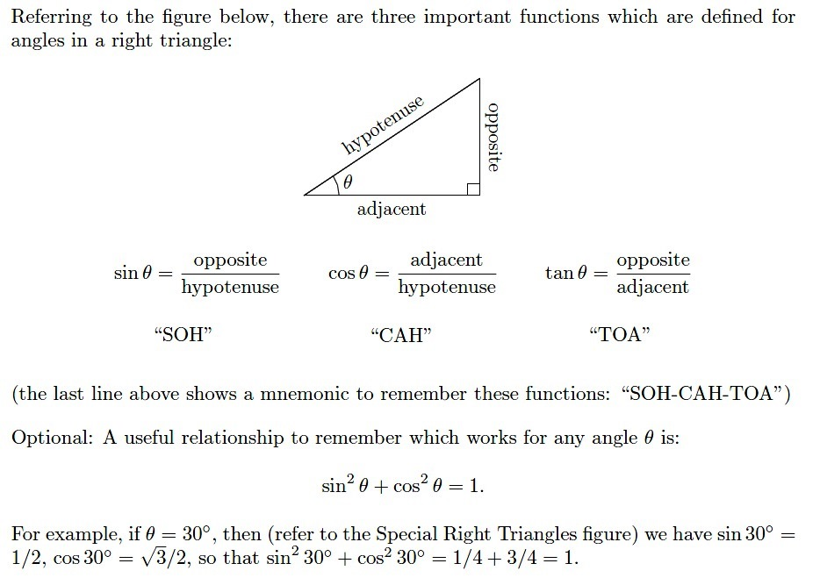

Circles

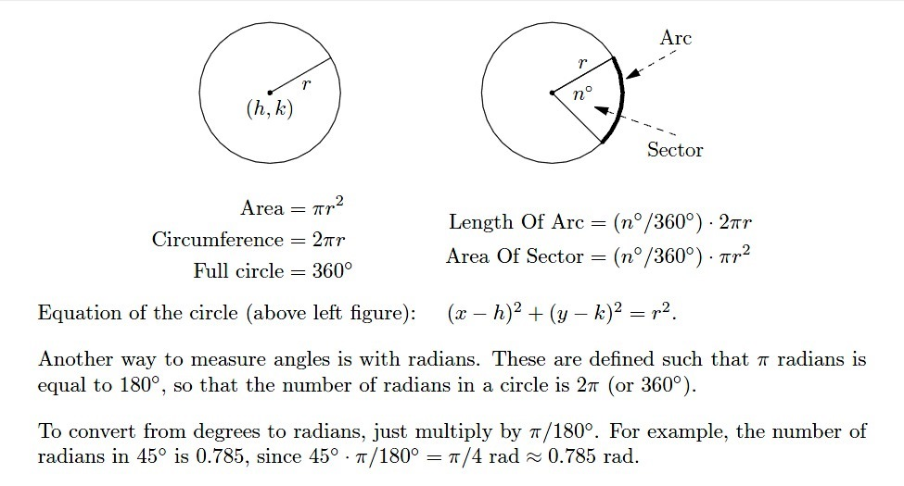

Rectangles

